Digital Egypt Builders Initiative
Final Project

Oil and Gold Prices Prediction

Presented by:
Student ID# | Student Name
 | Ahmed Bassiouni
21132600 | Lamiaa Selim
21093611 | Mohamed ElNaggar
 | Nourhan Habila
 | Sara Seoudi

Project Supervisor: Mohamed Hamed

May 2025

Table of Contents

Table of Figures iv
List of Tables v
Declaration vi
Acknowledgement vii
Abstract 1
1. Introduction 2
1.1 Problem Description 2
1.2 Research Objectives 2
1.3 Research Contribution 3
2. Literature Review 4
2.1 Introduction 4
2.2 Related Methods 4
3. Methods and Materials 5
3.1 Methodology Overview 5
3.2 Data sources 6
3.2.1 Market data 6
3.2.2 Forex rates 6
3.2.3 Egyptian market data 6
3.2.4 Global macroeconomic indices 6
3.2.5 Geopolitical Risk Indices (GPR) 7
3.2.6 Global Energy Data (World Bank API) 7
3.3 Technology Stack 7
4. Implementation 8
4.1 Data gathering and cleaning (collection_and_cleaning.ipynb notebook, ETL pipeline) 8
4.1.1 Data cleaning logic 8
4.1.2 Master table construction 8
4.2 Gold prices model (standalone_gold_model.ipynb) 9
4.2.1 Target Variable 9
4.2.2 Leakage Removal 9
4.2.3 Feature Engineering 9
4.2.4 Target Engineering 10
4.2.5 Train/Test Split 10
4.2.6 Model Configuration 10
4.3 Oil prices model (oil_model.ipynb) 11
4.3.1 Target Variable 11
4.3.2 Feature Engineering 11
4.3.3 Train/Test Split & Training 12
4.3.4 Next-Day Oil Price Prediction 12
4.4 Power BI Integration & Visualization 12
5. Results and Discussion 13
5.1 Model Performance Summary 13
5.1.1 Gold Price Model Results 13
5.1.2 Oil Price Model Results 14
5.2 Discussion 15
5.3 Limitations 15
5.4 Dashboard Analysis and Visual Insights 16
5.5 19
6. Conclusions and Future Work 19
References 20

Table of Figures
Figure 1: Creating master table code 8
Figure 2: Gold model target engineering features 9
Figure 3: Full model 10
Figure 4: Top features model 10
Figure 5: Brent oil predict for next day 12

List of Tables

Table 1: Methods for Predicting Oil and Gold 4
Table 2: Market data tickers and sources 6
Table 3: Global macroeconomic data 6
Table 4: Programming tools used 7
Table 5: Gold model feature engineering parameters 9
Table 6: Oil model feature engineering parameters 11

Declaration
We hereby declare that this project and the work reported herein was composed by ourselves and has not been submitted for any other degree or professional qualification. All sources have been acknowledged and referenced. The project implementation including data collection, cleaning, feature engineering, model training, evaluation, and documentation was carried out independently by the team as part of the DEPI Round 4 Final Project requirement.

Acknowledgement
The team would like to express sincere gratitude to our project supervisor Mohamed Hamed for his continuous guidance, technical mentorship, and constructive feedback throughout the program. We also extend our thanks to the DEPI Round 4 instructors and program coordinators for organizing a rigorous and applied learning experience that enabled us to build a real-world end-to-end machine learning system from scratch. This project represents the team's collective first step into applied machine learning, built with curiosity, persistence, and strong cross-functional collaboration from team members with backgrounds in shipping, engineering, finance, and technology.

Abstract
This project presents a complete data-to-prediction pipeline designed to forecast two of the world's most strategically important commodities: Gold (XAU/USD) and Brent Crude Oil (USD/barrel). The system spans three integrated phases:
- automated data engineering collecting from 10+ sources including APIs, web scraping, and manual downloads.
- Data cleaning and harmonization into a unified daily time series (2016–2026).
- Machine learning modeling using LightGBM with time-series cross-validation, advanced feature engineering, and strict leakage prevention.
Two parallel prediction models were trained and evaluated — one for gold price and one for Brent crude oil — each producing both a full-feature model and an optimized top-features model. The top-features oil model achieved a directional accuracy of 78.2% and MAE of 5.41 USD/barrel, while the top-features gold model achieved a directional accuracy of 82.4% with MAE of 159.47 USD/oz on the out-of-sample test period (January–April 2026).
Keywords: Gold Price Prediction, Oil Price Forecasting, LightGBM, Time-Series Machine Learning, Feature Engineering, DEPI

Introduction

Problem Description
Commodity prices — especially gold and crude oil — are among the most economically sensitive variables in global markets. At times of unrest, gold acts as a safe-haven asset, a hedge against inflation, and a barometer of geopolitical stress. On the other hand, Brent crude oil underpins the pricing of energy across the globe and directly affects production costs, transportation, and national economic balances — particularly in oil-dependent economies like Egypt.
Accurate short-term forecasting of these prices is of immense value to traders, risk managers, policymakers, and financial analysts. However, the complexity of price dynamics — driven by macroeconomic indicators, geopolitical events, currency fluctuations, equity markets, and cross-commodity correlations — makes reliable predictions challenging machine learning problem.
Both of the above resources make a pivotal key in Egyptian financial policy which is updated to reflect with worldwide events that impacts the Egyptian economy and forces us to react proactively to absorb the global impact of price’s changes.

Research Objectives
The primary objectives of this project are:
- To use the methods, we learnt across the program in data collection and manipulation in designing and implementing an automated, reproducible data collection pipeline aggregating 10+ heterogeneous data sources (APIs, web scraping, manual downloads).
- Build a robust ETL and cleaning pipeline that harmonizes all sources into a single, unified daily time series spanning 2016–2026.
- Build and construct an engineering feature capturing cross-asset relationships, volatility regimes, macroeconomic signals, and geopolitical risk.
- Train and evaluate LightGBM-based machine learning models for both gold and oil price direction and magnitude prediction
- Prevent data leakage to ensure the model only uses information available at prediction time and to elevate integrity of the model.
- Compare full-feature vs. top-features model performance using appropriate evaluation metrics (MAE, RMSE, R², MAPE, Directional Accuracy).

Research Contribution
This project is notable for its breadth of data integration — combining market data, forex rates, Egyptian local market indicators, multi-country macroeconomic data, geopolitical risk indices, and global energy data into a single modeling framework.
The Egyptian-local perspective (EGX30, USD/EGP exchange rate, CBE CPI) represents a distinctive contribution not common in standard commodity forecasting literature. The team, coming from diverse backgrounds including maritime shipping, engineering, and finance, brings applied domain knowledge into the feature design decisions.

Literature Review

Introduction
Gold has historically served as a store of value and a hedge against inflation, currency devaluation, and geopolitical instability. Since the collapse of the Bretton Woods system in 1971, gold has traded freely on international markets, with its price influenced primarily by US dollar strength, real interest rates, central bank reserves, and investor sentiment. Brent Crude Oil, sourced from the North Sea, serves as the primary global benchmark for oil pricing, with over two-thirds of the world's internationally traded oil contracts priced relative to Brent.
Both assets exhibit high price volatility and complex interdependencies with macroeconomic factors. The global financial crisis of 2008, the COVID-19 pandemic shock of 2020, Russia's invasion of Ukraine in 2022, and ongoing Middle Eastern tensions have demonstrated how rapidly prices can shift in response to real-world events. These characteristics make price prediction simultaneously challenging and commercially high value.
Unfortunately, with the begging of 2026 and after choosing this project, a huge global unrest emerged due to the events related to Hurmuz Straight and its global impact on both Oil and Gold prices which elevates the uncertainty in predictions.

Related Methods
Recent literature on commodity price forecasting demonstrates a clear trend toward ensemble tree-based models and deep learning approaches. The following table summarizes key methodologies and their reported performance characteristics:
Study / Method | Asset | Key Technique | Reported Performance
LightGBM-based ensemble | Oil | Gradient boosted trees, lag features | R² > 0.90 in sample
LSTM / GRU models | Gold | Deep learning time series | High in-sample, weaker OOS
Random Forest + macro features | Gold & Oil | Tree ensemble, macroeconomic inputs | ~75% directional accuracy
XGBoost + sentiment features | Brent Crude | Gradient boosting + NLP signals | MAE reduction ~15%
Hybrid ARIMA-ML | Gold | Statistical + ML combination | Improved trend capture

Table 1: Methods for Predicting Oil and Gold

The consensus from recent studies is that:
- Tree-based gradient boosting models consistently outperform linear and classical time-series models on commodity prices.
- Feature engineering — particularly lag features, rolling statistics, and cross-asset relationships — contributes significantly to prediction quality.
- Strict time-series cross-validation (no shuffling) is critical to avoid optimistic out-of-sample estimates. This project adopts LightGBM as the primary algorithm, consistent with the literature, while extending prior work by incorporating Egyptian local market indicators, geopolitical risk indices (GPR and AI-GPR), and a broader set of multi-country macroeconomic features.

Methods and Materials

Methodology Overview
The project follows the following steps:
- Phase (1): data collection and engineering:
  - Automated collection of needed data from different sources using different methods (APIs, web scrapping and manually).
  - Storing the raw data in common folder for future processing.
- Phase (2): data cleaning and harmonization:
  - This is done in parallel with phase (1).
  - Storing the data from 01.01.2016 till 01.05.2026.
  - Dealing with null and inconsistent values.
  - Tuned data storing of cleaned data into two folders (market and macro-economic data).
- Phase (3): machine learning (ML) modeling:
  - Creating the master table for all data for model’s training.
  - Feature engineering (cross-asset, lag, volatility, momentum).
  - Leakage prevention.
  - Time-Series CV + LightGBM Training.
  - Evaluation.
- Phase (4): in-depth visualization:
  - This is done in parallel with phase (3).
  - Using Power BI, descriptive visualization for the cleaned data which helps in understanding the story behind the data.
- Phase (5): Streamlit:

Data sources

Market data
Asset | Ticker | Source
Gold Futures | GCF | Yahoo Finance
Brent Crude | BZF | Yahoo Finance
WTI Crude | CLF | Yahoo Finance
OPEC Basket Price | POILBREUSDM | FRED (St. Louis Fed)
Oil Volatility Index | OVXCLS | FRED
Gold Volatility Index | GVZCLS | FRED
VIX (Fear Index) | VIX | Yahoo Finance
NASDAQ, Dow Jones, S&P 500 | IXIC, DJI, GSPC | Yahoo Finance
Shanghai, Tokyo, London, HK Indices | Various | Yahoo Finance
Silver, Copper | SIF, HGF | Yahoo Finance

Table 2: Market data tickers and sources

Forex rates
Daily exchange rates collected via yfinance for USD against: EUR, CNY, JPY, GBP, RUB, CHF, and NOK — key currencies for commodity pricing dynamics and safe-haven capital flow analysis.

Egyptian market data
Automated browser-based scraping using Selenium was applied to the Central Bank of Egypt (CBE) website to extract:
- USD/EGP Exchange Rate — daily historical data.
- Headline & Core Inflation (CPI) from CBE Excel reports.
- EGX30 — Egyptian stock market index from the official EGX website.
- XAU/EGP — Local gold prices sourced from investing.com (manual integration).

Global macroeconomic indices
Region | Indicators | Source
Egypt | CPI, Interest Rate | IMF API, CBE
USA | Fed Funds Rate, Treasury Yields (1Y–30Y), CPI, GDP, Dollar Index | FRED API
Euro Zone | Interest Rate, CPI, GDP | ECB API
Norway | Interest Rate, CPI, GDP, 2Y/10Y Yields | Norges Bank API, SSB API
China | CPI, Interest Rate, GDP | FRED API
Japan | CPI, Interest Rate, GDP, 2Y/10Y Yields | FRED API

Table 3: Global macroeconomic data

Geopolitical Risk Indices (GPR)
- GPR Index — measures adverse geopolitical events via newspaper article tallies, capturing military conflicts, terror threats, and political crises
- AI-GPR Index — AI-enhanced version of the daily GPR index, providing higher-frequency geopolitical signal.

Global Energy Data (World Bank API)
Energy production and trade indicators for 11 countries (US, Egypt, Germany, Norway, China, Japan, Russia, Saudi Arabia, Kuwait, Qatar, UAE) including: oil-based electricity production percentage, energy use per capita, fuel import/export as percentage of total trade, and gas-based electricity production percentage.

Technology Stack
Category | Tools & Libraries
Language | Python 3.x
Data & Wrangling | pandas, numpy
Web Scraping | selenium, webdriver-manager
Market Data APIs | yfinance, requests (IMF, FRED, ECB, Norges Bank, World Bank)
Machine Learning | scikit-learn, xgboost, lightgbm
Visualization | matplotlib, seaborn
Environment | Jupyter Notebook, VS Code
Model Serialization | joblib, pickle

Table 4: Programming tools used

Implementation

Data gathering and cleaning (collection_and_cleaning.ipynb notebook, ETL pipeline)
This notebook implements the full data collection and cleaning pipeline. Directory paths are configured programmatically using pathlib.Path, establishing four key locations: raw data/, cleaned data/market data/, cleaned data/macroeconomic data/, and ai model/.

Data cleaning logic
All datasets are processed through a standardized cleaning pipeline implemented in a reusable loading() function:
- Chronological Sorting — all records sorted from 2016-01-01 to present
- Continuous Daily Timeline — pd.date_range ensures no date gaps; every calendar day is accounted for missing Value Strategy — bfill applied to the first valid entry; ffill applied thereafter to handle weekends, market holidays, and reporting lags
- Date Normalization — mixed formats (MM/DD/YYYY, DD/MM/YYYY, YYYY-Q1) normalized to a consistent standard.
- Numeric Cleaning — symbols (%, $, ,) stripped and values cast to float
- Schema Standardization — every output CSV follows id | region | ticker | date | value
- Duplicates Removal — duplicate date entries detected and resolved (particularly in CBE exchange rate data).

Master table construction
In the beginning of standalone_gold_model.ipynb notebook, further cleaning actions were made to make all cleaned market and macroeconomic DataFrames are merged into a single master table using functools.reduce with pd.merge (outer join on the date key). The resulting master table is saved as master_table.csv in the ai model/ directory, forming the input to both modeling notebooks.
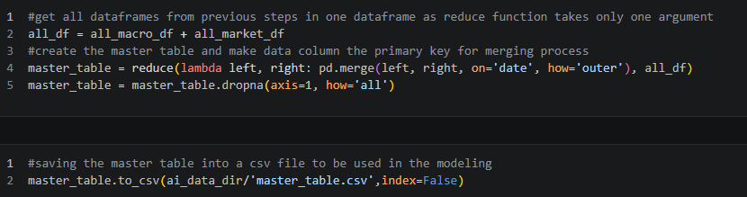
Figure 1: Creating master table code

Gold prices model (standalone_gold_model.ipynb)

Target Variable
Target column: gold_price_oz_usd (gold price per troy ounce in USD).

Leakage Removal
Features directly encoding same-day target information are removed. Leakage keywords include:
- open, high, low (same-day OHLC of the gold asset).
- gpr_event, ai_gpr_Unnamed (raw GPR components).
- gold_price_oz_egp (local gold price in EGP — same-day correlated).

Feature Engineering
Parameter | Formula | Economic Rationale
gold_usd_index | Gold × Dollar Index | Inverse correlation signal
gold_sp500 | Gold × S&P 500 | Risk-on/risk-off indicator
gold_vol_x_vix | Gold VIX × VIX | Combined volatility/fear signal
geo_risk_gold | AI-GPR × gold sensitivity | Geopolitical premium
silver_gold_ratio | Silver / Gold | Precious metals spread
gold_real_rate | Gold × (1 − US real yield) | Real interest rate sensitivity

Table 5: Gold model feature engineering parameters

Target Engineering
The prediction target is the 5-day rolling mean of log returns, shifted one day forward and clipped to ±4%.
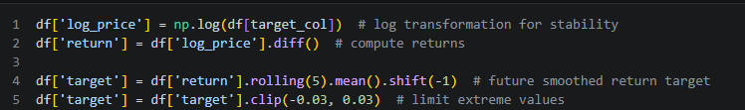
Figure 2: Gold model target engineering features

Train/Test Split
- Train set: all data up to 2025-12-30.
- Test set: 2026-01-01 to 2026-04-30 (4-month holdout).

Model Configuration
Full model (all features):
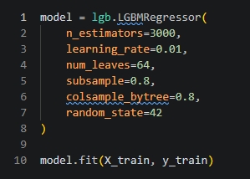
Figure 3: Full model
Top 15 features model (enhanced regularization):
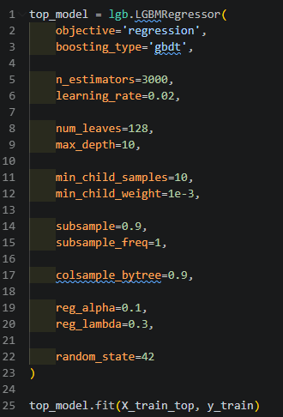
Figure 4: Top features model

Oil prices model (oil_model.ipynb)

Target Variable
As brent oil prices are the main energy sector driver in Egypt, the target column: brent_oil_price_usd (Brent Crude Oil price per barrel in USD).

Feature Engineering
Feature | Formula | Economic Rationale
net_energy_imports | Fuel imports − Fuel exports | Net energy dependency
opec_pressure | OPEC basket × Brent price | OPEC pricing power signal
geo_risk_oil | AI-GPR × oil sensitivity | Geopolitical supply risk
oil_vol_x_vix | Oil VIX × VIX | Combined fear/volatility
oil_sp500 | Brent × S&P 500 | Risk-on demand signal
oil_x_dxy | Brent × Dollar Index | USD inverse correlation
copper_oil_ratio | Copper / Brent | Industrial demand proxy
wti_brent_spread | WTI − Brent | Arbitrage/quality spread

Table 6: Oil model feature engineering parameters

Train/Test Split & Training
- Train set: up to 2025-12-31 (3,632 samples, 141 features)
- Test set: 2026-01-01 to 2026-04-30
- Top 20 features selected via LightGBM feature importance (split count)
- Both full-feature and top 20 models are serialized as .pkl files

Next-Day Oil Price Prediction
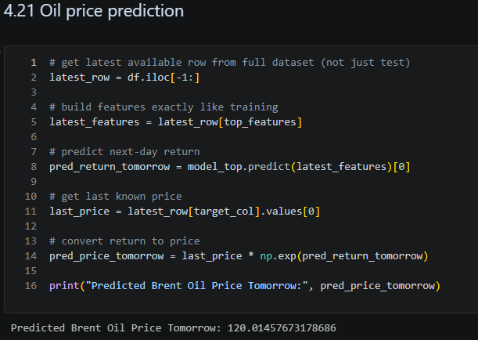
Figure 5: Brent oil predict for next day

4.4 Power BI Integration & Visualization

4.4.1 Data Preparation for Visualization
Refined Cleaning: After the initial ETL process using Pandas to eliminate duplicates and null values, the data was further refined using the Power BI Power Query (Transform tool).
Data Structuring: Data was restructured and normalized across a unified temporal dimension (Date-based) to ensure data integrity and enable effective filtering/slicing across different economic factors.

4.4.2 Dashboard Architecture
The dashboard was structured into three specialized modules to provide a holistic view of the market:
4.4.2.1 Intro (Market Intelligence Hub): Provides a high-level overview of global energy markets, integrating crude oil prices, equity indices, and regional consumption data.
4.4.2.2 Gold Analysis: Focuses on the asset's utility as a strategic buffer. It layers gold market movements against USD valuation, interest rates, and global geopolitical risk markers.
4.4.2.3 Energy & Oil: Maps Brent and WTI prices against volatility indices and trade metrics to assess regional vulnerability and market sentiment.
Detailed visual representations, trend charts, and comprehensive analytical insights derived from these dashboards will be further discussed in the Results and Discussions section.

Results and Discussion

Model Performance Summary
Both models were evaluated on a fully held-out test period: January 1, 2026 to April 30, 2026 — a 4-month window never seen during training or cross-validation.

Gold Price Model Results
Metric | Full Model | Top-15 Features Model
MAE (USD/oz) | 284.22 | 159.47
Directional Accuracy | 79.0% | 82.4%

Table 7: Evaluation of gold model

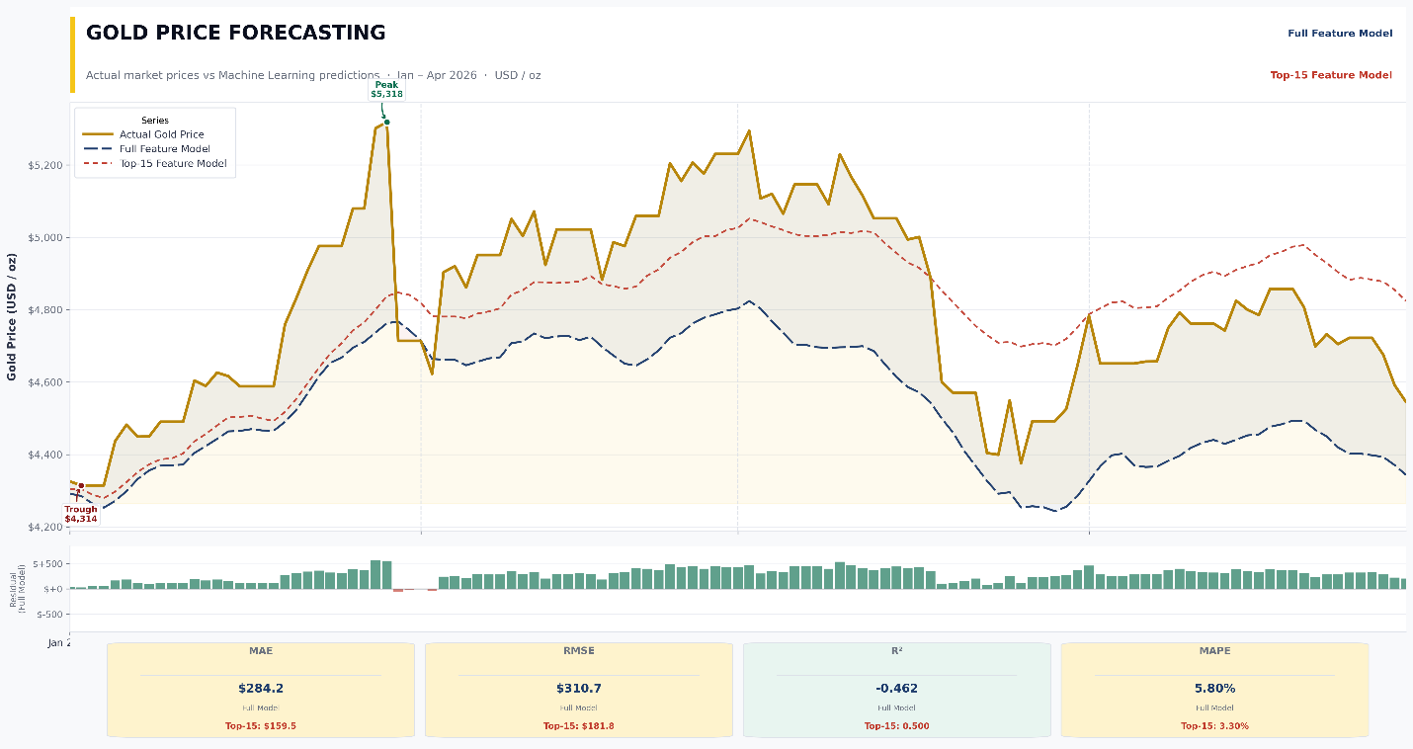
Figure 6: Gold model comparison

Oil Price Model Results
Metric | Full Model | Top-20 Features Model
MAE (USD/barrel) | 11.19 | 5.41
Directional Accuracy | 77.3% | 78.2%

Table 8: Evaluation of oil model

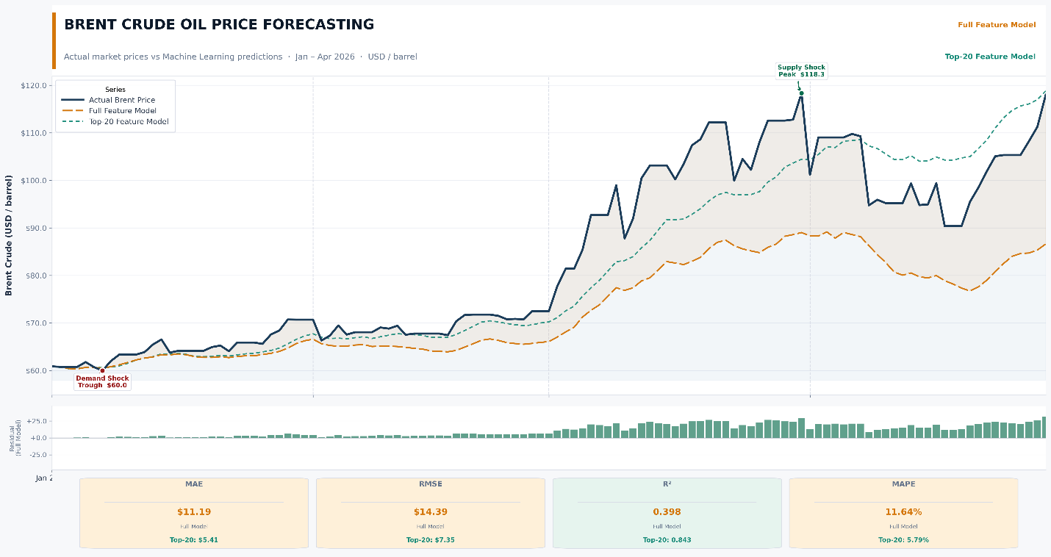
Figure 7: Evaluation of oil model

Discussion
Gold and oil predictions are one of the toughest challenges for finance professionals and quant engineers due to the high volatility in prices that may change dramatically based only on one political statement or one joke from well-known people. And with the begging of 2026 this was set to field to prove that nothing can limit the shocks in financial markets due to global unrest.
The significantly lower MAE and higher directional accuracy of the top-features model in both cases validates the feature selection approach. With 140+ raw features (including many low-importance macroeconomic indicators at quarterly resolution), the full model is prone to overfitting subtle patterns that do not generalize to new market conditions. Reducing to 15–20 high-importance features force the model to rely on the most economically robust signals — recent momentum, cross-asset correlations, and geopolitical risk.
A directional accuracy of 82.4% for gold is commercially meaningful — it correctly identifies whether gold will rise or fall on approximately 4 out of every 5 trading days. For oil, the Top 20 model MAE of 5.41 USD/barrel represents approximately a 4–6% error relative to typical Brent crude prices in the test period, which is an acceptable range for short-term price trend forecasting.

Limitations
- Egyptian macroeconomic features (EGX30, USD/EGP, CBE CPI) had limited direct impact on global price prediction but add value for local-currency projections
- Some data sources (CBE website, EGX30 portal) require active internet connectivity and may experience downtime; manual CSV fallbacks are documented in notebook cells
- The models predict 5-day average returns rather than absolute next-day prices, which introduces reconstruction errors in price-level comparison
- The current implementation does not account for real-time market microstructure effects (bid-ask spreads, liquidity)

Dashboard Analysis and Visual Insights
5.4.1. Introduction
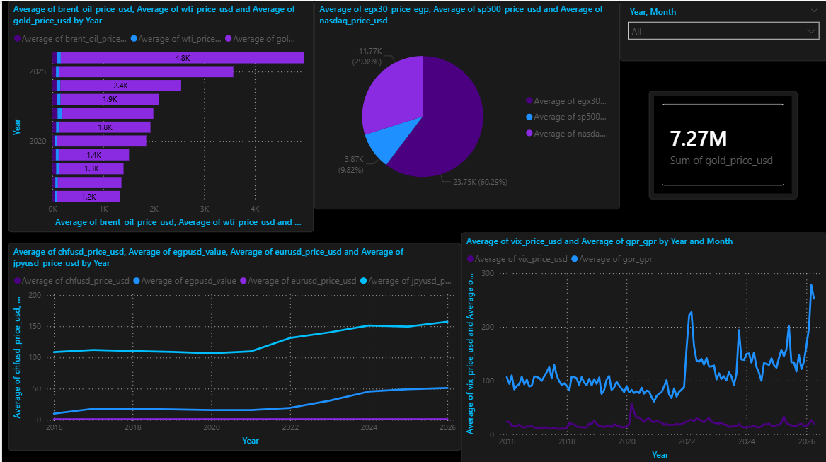
Fig 8: Introduction page
This comprehensive Power BI dashboard serves as a centralized intelligence hub for monitoring and analyzing global commodity and energy markets. The dashboard integrates macroeconomic indicators, commodity benchmarks, currency fluctuations, and regional energy consumption statistics into a unified analytical environment that enables users to explore complex market dynamics through interactive visualizations.
The analytical framework was implemented in three primary stages. First, heterogeneous datasets were normalized and aligned across a unified temporal dimension to ensure consistency, accuracy, and reliable cross-market comparisons. Second, multi-layered visualizations were developed to overlay commodity price trends with volatility indices, geopolitical risk indicators, and equity market movements, enabling differentiation between fundamental market behavior and sentiment-driven fluctuations. Third, comparative regional energy metrics were incorporated to evaluate energy dependency, trade exposure, and electricity generation patterns across multiple countries. By integrating energy-specific indicators with broader macroeconomic variables, the dashboard transforms high-dimensional financial and economic data into actionable insights that support strategic decision-making, market interpretation, and risk assessment.
- Gold Market Analysis
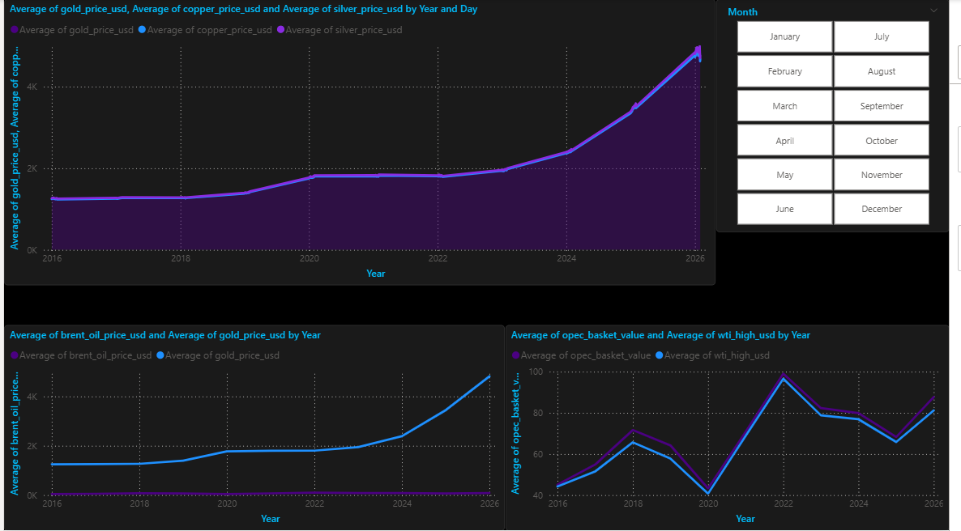
Fig 9 :
The Gold Analysis module focuses on evaluating gold price behavior as a strategic safe-haven asset under varying economic and geopolitical conditions. The dashboard combines spot gold prices with volatility indicators and macroeconomic variables to analyze how gold reacts to fluctuations in market sentiment and global uncertainty.
The analytical process involved aligning gold price movements with several key drivers, including:
• USD valuation and currency strength,
• Equity market performance,
• Interest rate environments,
• Geopolitical Risk (GPR) indices,
• Market volatility indicators such as VIX and GVZ.
Trend visualizations reveal that gold prices experienced significant upward momentum during periods of heightened geopolitical instability and increased market volatility. Correlation analysis further highlights the inverse relationship between gold prices and USD strength, while simultaneously confirming gold’s role as a defensive asset during periods of equity market stress.
Additionally, comparative visualizations between gold, silver, and copper prices provide insights into broader precious metal market behavior and industrial demand dynamics. These visualizations enable stakeholders to identify hedging opportunities and evaluate gold’s effectiveness as a portfolio risk mitigation instrument.

- Energy and Oil Market Analysis
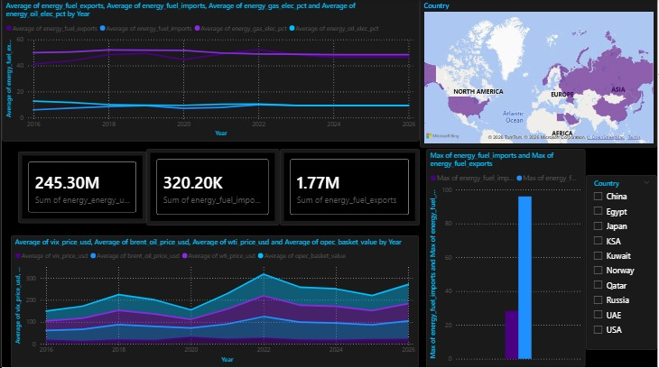
Fig 10:
The Energy & Oil module delivers a multi-dimensional analysis of global energy market behavior through the integration of oil benchmarks, regional energy indicators, and macroeconomic variables.
The dashboard is built upon three core analytical pillars:
Global Oil Benchmarks
Including Brent Crude Oil, WTI Crude Oil, and OPEC Basket prices.
Regional Energy Indicators
Including fuel imports/exports, energy dependency ratios, and electricity generation mixes.
Macroeconomic and Financial Variables
Including USD exchange rates, stock market indices, volatility indices, and geopolitical risk indicators.
The visualization layer tracks oil price trends over time while simultaneously overlaying volatility indicators such as OVX and VIX to distinguish between supply-demand fundamentals and sentiment-driven market reactions. Significant market disruptions, including geopolitical conflicts and economic uncertainty, are clearly reflected through sharp increases in volatility and price fluctuations.
Regional trade and dependency metrics further illustrate how different economies are exposed to global energy shocks. Comparative charts demonstrate the varying degrees of fuel import dependency and energy production structures among selected countries, enabling a more comprehensive understanding of regional vulnerability to global commodity price movements.
Furthermore, the dashboard’s correlation analysis highlights the interaction between oil prices, USD fluctuations, and geopolitical risk indicators. These relationships provide valuable insight into how external macroeconomic and political events influence commodity market behavior and contribute to price instability.
Overall, the Energy & Oil module transforms complex economic and energy-related datasets into an interpretable analytical framework that supports both strategic forecasting and real-world market analysis.

Conclusions and Future Work

References
- Federal Reserve Bank of St. Louis. FRED Economic Data [Data set]. https://fred.stlouisfed.org
- Yahoo Finance. Historical market data [Data set]. https://finance.yahoo.com
- Central Bank of Egypt. Exchange rates and inflation data [Data set]. https://www.cbe.org.eg
- World Bank. World Development Indicators [Data set]. https://databank.worldbank.org
- European Central Bank. Statistical Data Warehouse [Data set]. https://sdw.ecb.europa.eu
- Norges Bank. Statistical data [Data set]. https://www.norges-bank.no

